How to Verify the new UPI link

According to SEBI’s latest guidelines, all payments to SEBI-registered intermediaries (like brokers, AMCs, and RTAs) must be made only through validated UPI IDs that end with @valid followed by Bank/PSP name.
The format: IntermediaryName.CategoryCode@validBank/PSP

Log in to the SEBI Website and click on SEBI Check on the page

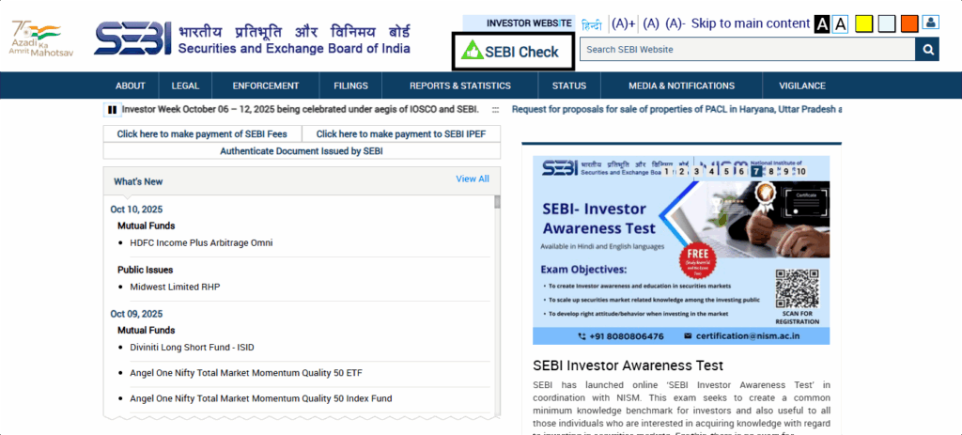

Choose whether you want to verify the UPI using Photo/Type



Click on TYPE and click verify

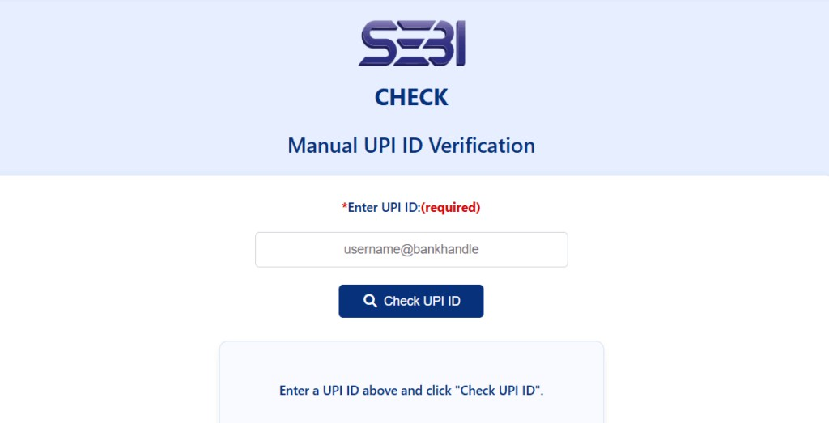

If the entered UPI is valid

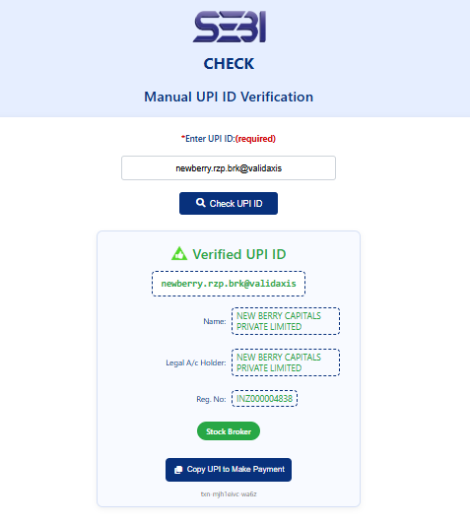

If the entered UPI is invalid

